1. Introduction

With the development of technology, curiosity about fundamental physics of human body is increasing day by day. Motion tracking system is one of these developments. Motion tracking system, camera systems and analysing methods, are crucial to collect data from human body with low error and to get a meaningful output. This technology allows us to understand the human body and to make interpretation about dynamics in various topics. These topics can be related with sport science, statitistical projects and health.

Nowadays, in medical treatments process, technological devices are used commonly such as MR machines and surgery robots. The advantage of using technology in medicine is diagnosis and treatment period is getting shorter with a high accuracy. Especially in physical therapies, the correct diagnosis and therapy methods can be determined by using motion tracking systems. However, these systems are not used commonly because of their costs and difficulties of using them. Therefore, we can see only motion tracking systems in advanced laboratories.

The aim of this project is to find cheaper and easier to use movement analysis framework with sufficient success. Under the supervision of Asst. Prof. Dr. Mehmet Türkan and Asst. Prof. Dr. Şermin Tükel, we decided to build a framework for human body and motion anlysis using Microsoft Kinect V2.

1. Devices

# Vicon (?)

Both in the animation, sports and health industry, the most common device that is currently being used is the Vicon MX system and Vicon Nexus software by Vicon Industries Inc.. The system consists of multiple IR cameras that interact with the special markers put on the objects, in this case human body, and captures their spatial data with respect to time.

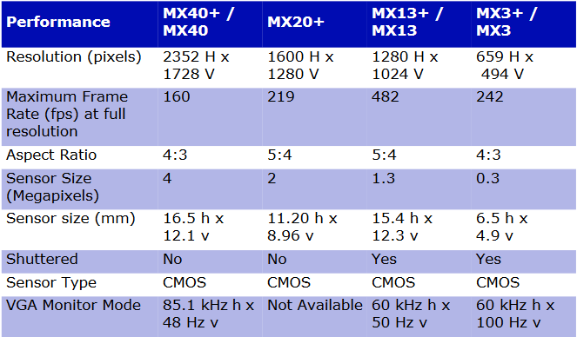

http://bdml.stanford.edu/twiki/pub/Haptics/MotionDisplayKAUST/ViconHardwareReference.pdf

# Microsoft Kinect V1

Microsoft developed Kinect V1 as a peripheral controller for a video game console Xbox 360 in the year 2010, however the Windows version was released in 2012 along with its SDK. With its built – in IR (320 x 240) and RGB Sensors (640 x 480 @30 fps), It’s been widely used in researches in the field of 3D body posture analysis and motion tracking.

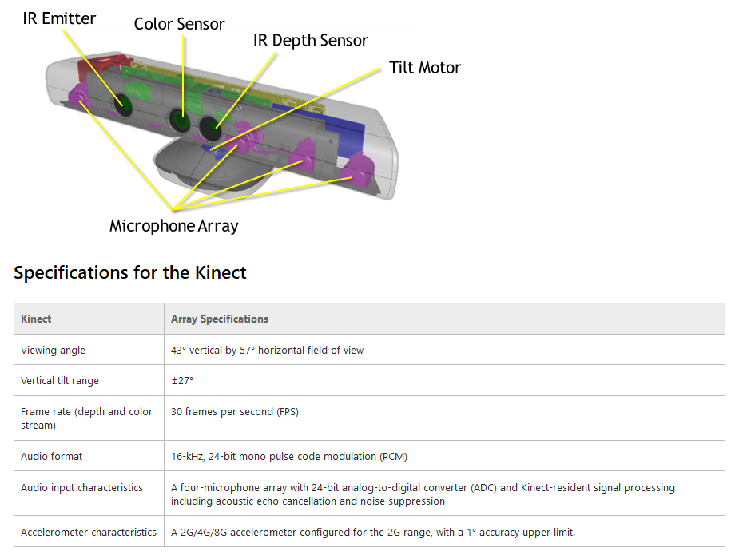

# https://msdn.microsoft.com/en-us/library/jj131033.aspx

# Microsoft Kinect V2

In the year 2013, Microsoft Released Kinect V2 for its new console, Xbox One and after a year, for Microsoft Windows with the SDK 2.0. The new system was based on a similar but improved hardware.

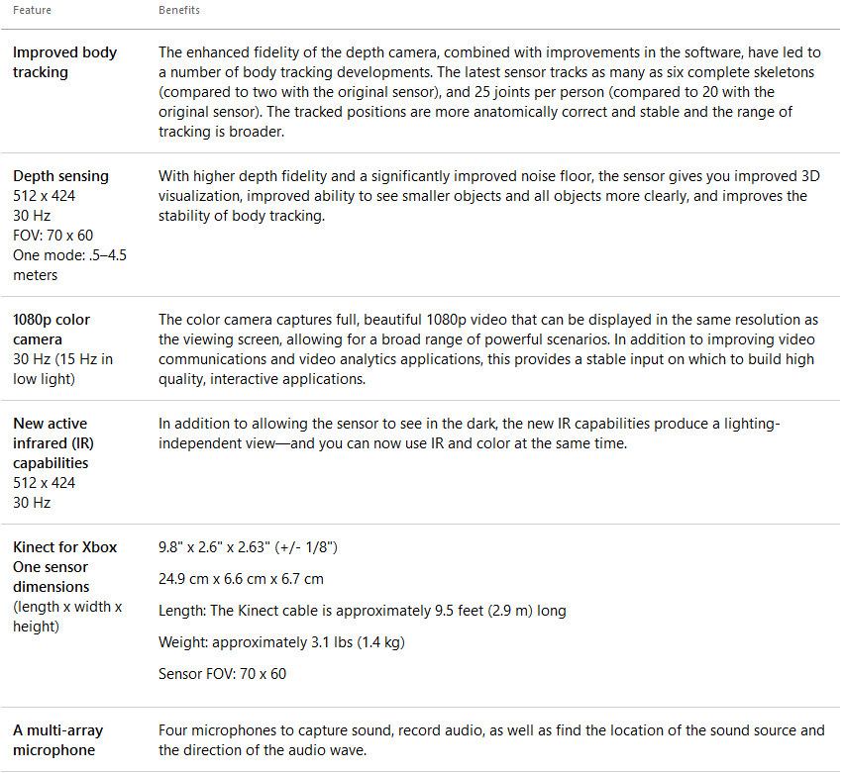

https://developer.microsoft.com/en-us/windows/kinect/hardware

Although the marker - based Vicon MX system, is accurate -enough that it is taken as the gold standard reference by many researchers, its complexity and costly setups confine its usability. As an alternative, the non – marker – based system, Microsoft Kinect provides a cheaper and easier to use system with high enough accuracy in certain applications, especially Kinect V2.

1. Literature Analysis

# Comparative abilities of Microsoft Kinect and Vicon 3D motion capture for gait analysis

**ABSTRACT**

The purpose of the study was to assess the validity of the Microsoft Kinect V1 with Brekel Kinect software in comparison to Vicon Nexus for sagittal plane gait kinematics. Subjects were 9 males and 11 females, and the objective was to walk and jog at three different velocities on a treadmill to measure hip and knee peak flexion and extension and stride timing. Generally, Kinect estimated the gait correctly, under – estimated the joint flexion and over – estimated the joint extension. Kinect and Vicon hip angular displacement correlation was low with a high error. Knee measurements of the Kinect were also not consistent enough for clinical assessment. Kinect and Vicon stride timing correlation was high with a low error. Kinect showed more consistency for lower velocities. Advanced developments must be applied on Kinect for clinical use.

**INTRODUCTION**

The hypothesis we had was there were no significant differences between Kinect and Vicon measurements.

**METHOD**

Subjects were 20 healthy adults (nine males, 11 females; 27.4±10.0 years, height 169.4±10.9cm; leg length 85.6±6.2cm) and regularly participated in moderate-to-vigorous activity. They were free of any physical condition or limitation that prevented them from walking or jogging on a treadmill.

10 – camera Vicon MX system was used to collect the data with the Vicon Nexus 1.7 software at 120 Hz along with the Microsoft Kinect V1 using Brekel Kinect software at 30 – 37 Hz (assumed to be steady at 30 Hz). For Vicon MX is a marker – based system, the subjects wore a full body suit with markers on. Instrument reliability tests applied on the Vicon showed [(ICC) (3, k) r = 0.998] and (SEM = 1.83˚), proving it to be suitable to be the gold – standard. Kinect was positioned at a 45˚ to the left of the treadmill for a clear vision.

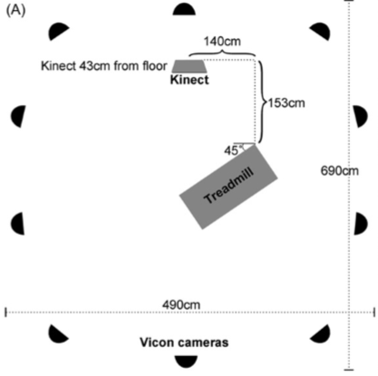

The subjects took between 10–40 steps per leg on the treadmill at three velocities: 3.0mph (4.83 kph, slow walk), 4.5mph (7.24 kph, brisk walk to slow jog) and 5.5mph (8.85 kph, medium to quick jog).

The output of the Vicon MX system was fed into an FIR filter using Vicon Nexus and the angles were measured using LabVIEW 7.5. Stride timing was defined as the time from peak hip/knee flexion to peak hip/knee flexion of the same limb.

At the analysis part, outliers were identified using Cook’s D, lever and studentized deleted residual values and removed. SD values were calculated for timing and displacement for each knee’s and hip’s peak flexion and extension at three velocities for each subject. Two – tailed t – tests (p < 0.05) were used to compare average Vicon and Kinect peak angular displacement and stride timing among individuals at the three velocities. Variability of Kinect and Vicon measurements were assessed by SD comparisons across individuals using two-tailed t-tests. Pearson product moment correlation coefficients were used to separately compare the angular displacements and stride timing of Kinect and Vicon at each velocity to determine their correlation strength.

Agreement between Kinect and Vicon measurements was assessed as described by Bland and Altman, by determining the mean (SD) difference between paired data points, which was referred as the error.

The percentage of missed steps by the Kinect system for each subject at each joint was calculated, mean of the data for the right and left hip and knee were determined and percentage missed steps between joints and limbs were compared using two – tailed t – tests. To determine whether the Kinect sensor tracked subjects of a particular size more accurately, percent missed steps were compared to three aspects of body size: height, leg length and body ratio (height/leg length).

To identify linear relationships between percent missed steps and size, Pearson product-moment correlation coefficient calculations were used.

**RESULTS**

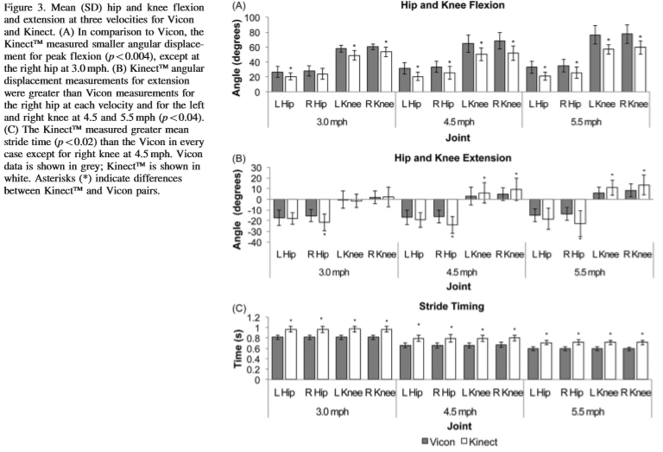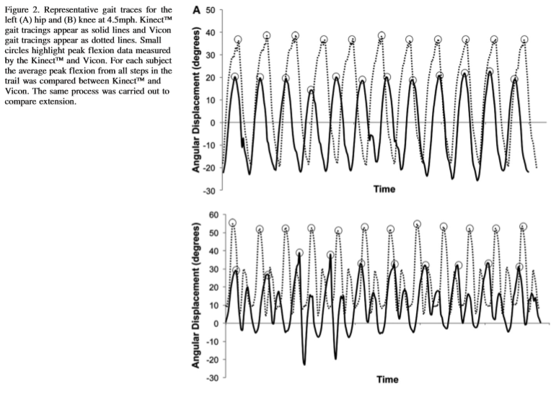

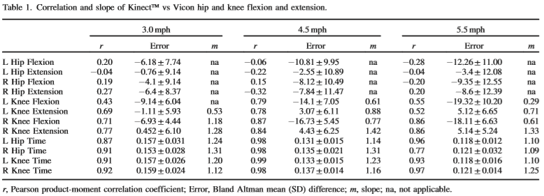

On average, 8 – 18% of the steps were missed by Kinect V2 and apparently the difficulty of tracking occurred when the knees crossed. Mean %missed steps did not differ related to left or right, hip or knee, or velocity (p > 0.05). At 6.6% of the trails, %missed steps was greater than 30%. Correlations between %missed steps and height, leg length or body ratio were poor (r < 0.50).

**DISCUSSION**

It was found that, the Microsoft Kinect V1 with Brekel Kinect software was generally able to track lower limb sagittal plane motion and produce representative gait traces with a varying accuracy, which makes insufficiently accurate for clinical use.

The Kinect did not produce consistent hip measurements, but knee measurements were better correlated compared to Vicon however neither are consistent enough for clinical applications. Kinect and Vicon stride timing measurements were often well correlated and with some slight adjustments to the software the Kinect may be a clinically acceptable tool to collect temporal gait measurements.

# Automated Evaluation of Upper-limb Motor Function Impairment using Fugl-Meyer Assessment

**ABSTRACT**

The Fugl – Meyer assessment is the most popular test for evaluating upper extremity motor function in stroke patients. This paper proposes a novel automated FMA system to overcome labor – intensive and time – consuming process of the test. A Microsoft Kinect V2 and force sensing resistor sensors were used to collect the data for the rule – based binary logic classification algorithm, based on the linguistic guideline of the FMA, for evaluation. The proposed system can automate 79% of the FMA tests. In clinical trials conducted with nine stroke patients, the proposed system exhibited high scoring accuracy (92%) and time efficiency (85% reduction in clinicians’ required time).

**INTRODUCTION**

The FMA has been used to evaluate upper extremity motor function, and it exhibited high inter – rater and intra – rater reliability, how ever it is labor – intensive and requires conductions of clinicians and takes at least 30 minutes.

Current automated tests used on stroke patients require body – worn sensors which are discomforting and machine learning algorithms that are fed by large amount of reliable data, which is hard to acquire in stroke disease. Also, relatively higher number of tests in FMA makes It a more reliable choice for evaluation.

This paper proposes an automated upper extremity motor function assessment system that is practical enough to be used in clinics using 2 no – body – worn sensors implementing 26 target FMA tests. The developed rule – based binary logic algorithm to overcome the limitations of machine learning. The accuracy and time efficiency of proposed system are evaluated through clinical experiment involving nine stroke patients.

**METHOD**

The FMA tests are classified into four groups based on a clinical evaluation method, as summarized in Table I. The clinician directs a patient to perform in tests of G1 group. G2, G3 and G4 tests require a clinician’s tug, force application and resistance sensing respectively.

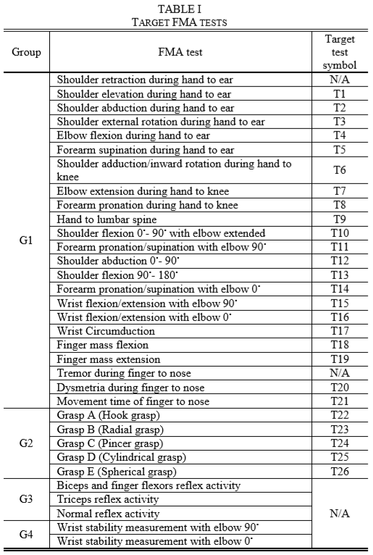

The requirement for the interaction of a clinician makes automation of G3 and G4 hard, however G2 can be implemented using a widely used grip strength measuring sensor, FSR.

For the evaluation of the G1 tests, joint angles, segment rotation, landmark position and hand open/close data must be gathered. For practicality reasons, Kinect V2 was picked over the famous IMU, a body - worn sensor system.

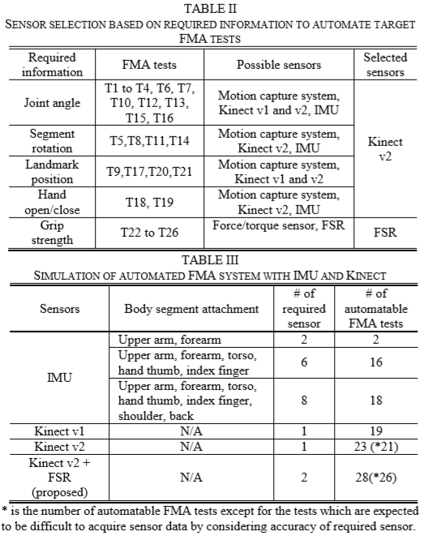

The FMA test has 3 types of criterions: FVa, FVb, and FM , which group the tests as stated in the Table IV.

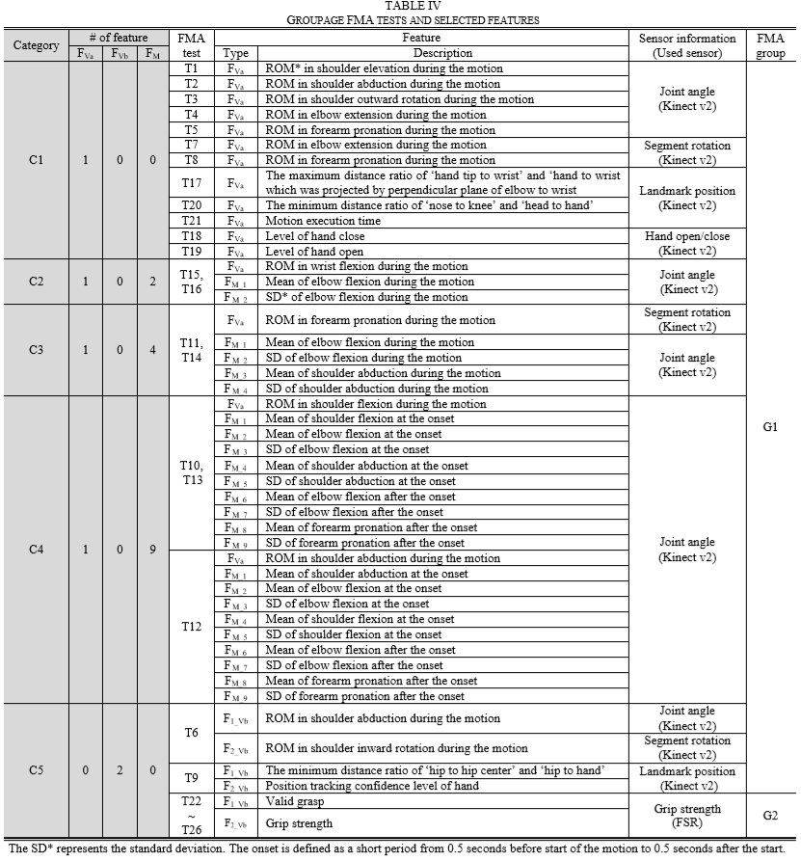

Calculating joint angles and segment rotation requires pre – processing of raw data collected by Kinect v2. A joint angle was calculated using a target landmark and its proximal/distal landmark position. As the Kinect v2 SDK provides a quaternion form of segment rotation, we converted it to a roll angle for simplification.

Based on joint angles and segment rotation, several features (ROM, motion execution time, and mean/SD) can be calculated, as shown in Fig. 1.

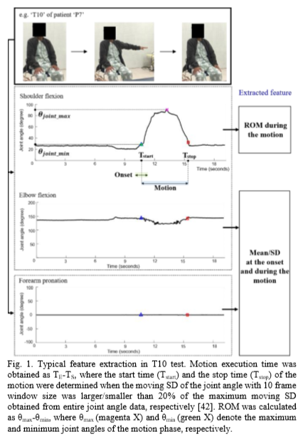

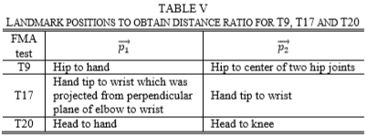Several tests (T9, T17, T20) use landmark position. Table V shows the way position vectors are determined in each test to calculate the distance ratio. The hand open/close state was only taken into consideration when the Microsoft SDK 2.0 showed a high level of confidence.

In this study, the linguistic guideline for the target FMA tests was converted into binary logics and implemented a classification algorithm based on these logics to assign FMA scores using extracted features. According to the role of each feature type, an FVa feature is expressed using two binary variables (xva_1 and xva_2) while FVb and FM features are expressed using a single binary variable (xvb and xM). In general, xva_1 and xva_2, xvb, and xM indicate the level of motion task performance, the validity of grasp motion, and the success of a posture maintaining task, respectively. For instance, in T16, xva_1 and xva_2 are determined as (0, 0), (1, 0) or (1, 1) to represent the low, medium, or high levels of wrist flexion motion, respectively; x1M and x2M are determined as 0 or 1 to represent the success /failure of the 0° elbow flexion posture maintaining task.

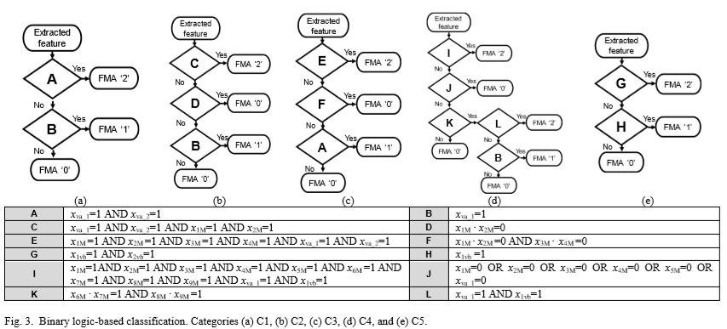After the analysis, we found that the decision logic structure of all FMA tests corresponding to each category (from C1 to C5) is the same, as shown in Fig. 3.

The participants are 6 males and 4 females; age: 58±16.5 years, each with stroke disease with MMSE score > 15. One of the patients was excluded from the data because of her denial to accomplish the tests.

The subjects set on a chair and ask to perform the tasks that are shown in a video on the screen in front of them. Based on the observation of a subject’s movement, the clinicians individually determined the scores for each test and assigned a score based on agreement to minimize the effect of imperfect inter-rater reliability of the FMA. After all target FMA tests supported by the proposed system (Table I) were conducted, the remaining seven tests were directly performed by the clinicians without the proposed system.

To evaluate the scoring accuracy of the proposed system, percent agreement and Cohen’s kappa coefficient (k) were calculated by comparing the FMA scores obtained from the system and clinicians. In addition, to confirm whether the 26 automated FMA tests conducting using the proposed system could represent all 33 FMA tests, a correlation analysis was conducted by calculating the Pearson correlation coefficient (r) between the total score of all 33 tests assigned by the clinicians and the total score of 26 tests assigned by the proposed system. SPSS version 20 was used for all statistical analyses.

**RESULTS**

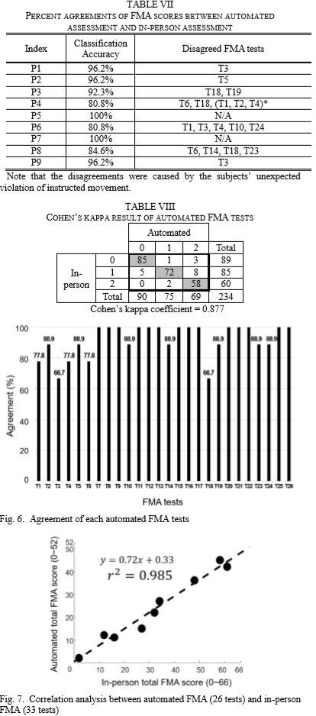The installation time of the system was approximately 330 seconds.

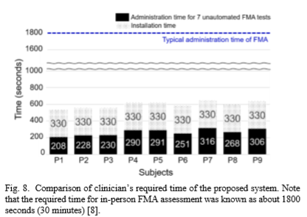

**DISCUSSION**

The proposed system proves it self to be time-efficient compared to other automated systems. Having no need for a large amount of data, makes it practical for clinical usage.

The accuracy is considerably high, which indicates the system can assess upper – limb motor function in a manner like a clinician’s. The inaccuracy of T5 and T14 were caused by the low precision of thumb tracking of Kinect v2’s with SDK 2.0. Moreover, the contracture results in inaccurate measurement of the hand open/close state by Kinect (T18 and T19). Some of the other inaccuracies can be overcome by simple adjustments like wearing tight clothes etc.

The extremely high correlation between the total score of the automated FMA tests and that of the in-person FMA tests indicates that the proposed system can adequately estimate complete FMA scores despite a few unautomated FMA tests.

This study proposed an automated FMA system for upper extremity motor function assessment in stroke patients. For developing a clinically relevant system, 79% of the FMA tests were automated through optimized sensor selection, and approximately 90% scoring accuracy was achieved by employing a rule-based binary logic classification algorithm without learning procedures. The proposed system can reduce a clinician’s required time for the FMA by more than 85%, which would contribute to frequent evaluation of upper-limb motor function and improvement in upper-limb intervention for rehabilitation.

# Assessing Upper Extremity Motor Function in Practice of Virtual Activities of Daily Living

**ABSTRACT**

The aim of this study is to investigate the validity of using Kinect V1 camera system to measure upper extremity (UE) motor function during performance of virtual practices of daily living (ADLs). In this study, there are fourteen hemiparetic stroke patients performing virtual practices with a Virtual Occupational Therapy Assistant (VOTA). Patients control an avatar to do tasks and sub-tasks. During the performance of ADLs, a Kalman filter-based human motion tracking algorithm is employed to measure kinematic values of UE joints in real-time.

And in order to check the validity by using statistical data, Spearman’s rank correlation analysis is employed for comparison between VOTA and Wolf Motor Function Test (WMFT).

**APPROACH**

**Virtual occupational therapy assistant:**

VOTA is developed as a home health rehabilitation program. By using the VOTA, patients can perform daily activities (dressing, shopping, food preparation, transportation, using a telephone etc.) in a virtual world as a part of the rehabilitation program. Kinect camera detect the UE joints movements of a human to control the avatar in the virtual world. The advantage of VOTA is that patients can continue to follow rehabilitation program more comfortable psychologically.

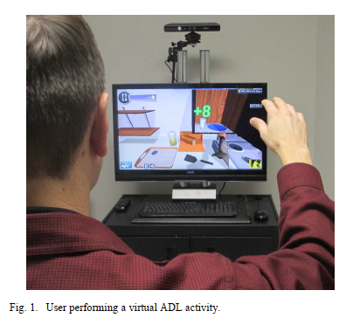

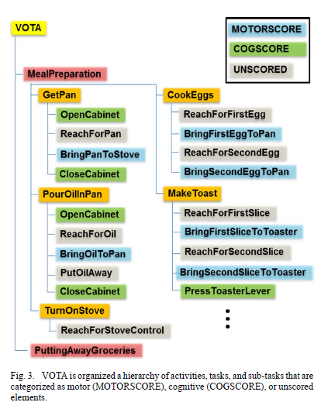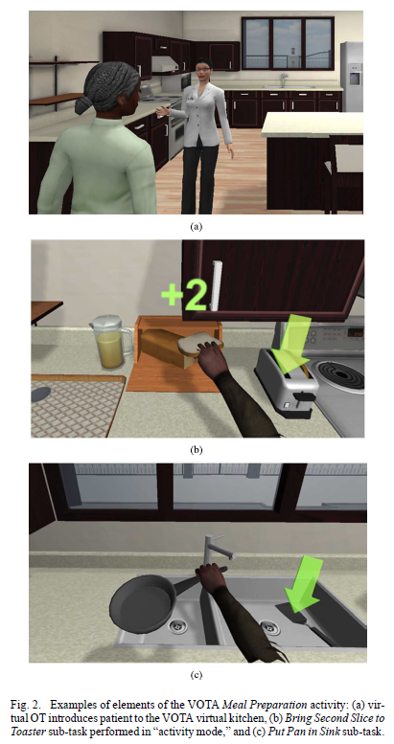

Virtual daily living activities consist of different types and difficulty level of tasks and subtasks in a certain hierarchy. Sub-tasks are categorized as motor (MOTORSCORE), cognitive (COGSCORE), or unscored elements. For this validation test study, MOTORSCORE metrics are the focus. Because we can use metrics of some specific movements by using a camera, so all of the joint displacements and movement angles cannot be captured.

**UE tracking filter:**

Microsoft Kinect SDK is sufficient for gaming; however, it does not provide all necessary information for VOTA application. For kinematic tracking, velocities and angular rates of joint movements are required. Therefore, unscented Kalman filter (UKF) based pose estimation algorithm is used to produce needed data.

Dynamic state vector consists of four primary sub-vectors.



UE joint angles, rates, and accelerations

of the left and right arms, respectively. Thus



Newton's (dot) notation to indicate differentiation with respect to time. UE joint angles are estimated in a swing twist parameterization that is described as



Distance (between joints) vector;



The collarbone is like a reference to estimate the positions and connections of joints and bones. Therefore, this sub vector denotes the pose (position, yaw, and pitch) of the collarbone line segment that connects the shoulder joints.



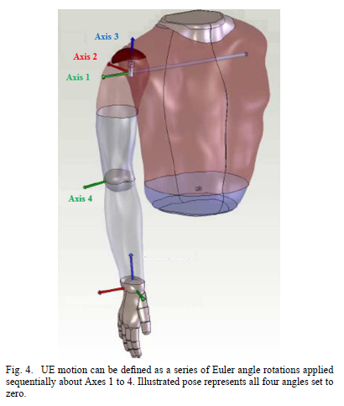For the results, the origin at the sensor focal plane is assumed the global reference frame.

In this study, elbows and shoulders are important, hand articulation is not included because of the limitations of the Kinect sensor.

The next step is generating the swing-twist parameterization by using UKF solution. The process model of the UKF describes how the state vector evolves with respect to time.

The measurement is comprised of the user’s shoulder, elbow and wrist joint position as in



**UE motor performance metrics:**

For each MOTORSCORE sub-task, the metrics provided by UKF solution are used to calculate the validity. Motor function related metrics are,

a) duration, sub-task completion time in seconds;

b) normalized speed (NS) (percent)—mean speed achieved divided by peak speed during performance of each subtask;

c) movement arrest period ratio (MAPR) (percent)—percentage

of time that speed exceeds a threshold percentage of peak speed during performance of each sub-task.

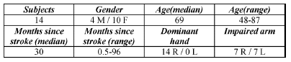For this study, 31 stroke patients are participated.

**METHODS**

**Protocol:**

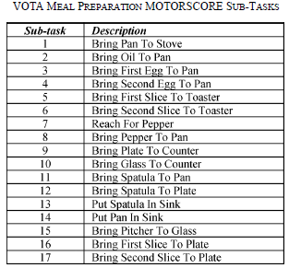Practice of *Meal Preparation* is included 17 MOTORSCORE sub-tasks, and patients were asked to use their stroke-affected arm to perform this practice in 4 trials.

The next figure shows an example of participant data captured and processed by VOTA in the fourth session. This example is related with the speed versus time for a *Bring Second Slice to Toaster* sub-task, and the speed is calculated from point to point measurements of joints.

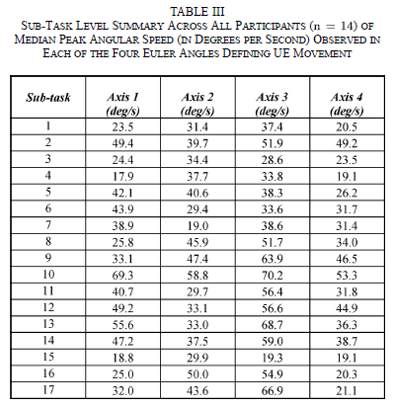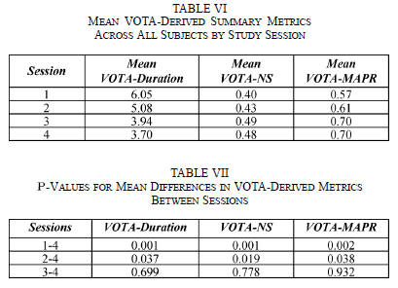**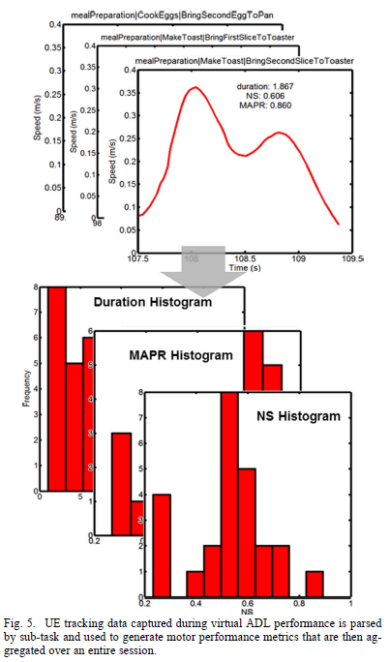RESULTS**

According to tables, we can say that Kinect cameras sensors can provide sufficient and reliable data about motor learning of UE joints for virtual rehabilitation process, although there are some limitations of Kinect system. However, to be able to see better results, these tests should be repeated time to time, therefore, in our results we cannot see the obvious changing as a clue of motor learning.

# Validity of The Microsoft Kinect for Assessment Of Postural Control

**ABSTRACT**

Clinical and classical methods of assessing postural control provides important information about posture of a person. However, these methods are not high-quality methods to assess postural control because of lack of accuracy. The researchers want to use Microsoft Kinect v1 system, because by using Kinect cameras, they can set up cheaper, portable and easy-to-use real-time system. The aim of this research and the article is validity checking of Kinect v1 system by comparing with a multiple-camera 3D motion analysis (VICON) system as a benchmark. Validation process covers some clinical postural tests such as forward reach test, lateral reach test and single-leg-eyes-closed test. According to values of the Microsoft Kinect system and 3D Vicon system statistical data should be comparable inter-trial reliability (ICC difference = 0.06 ± 0.05; range, 0.00–0.16) and excellent concurrent validity, with Pearson’s r-values >0.90 for the majority of measurements (r = 0.96 ± 0.04; range, 0.84–0.99).

**METHODS**

**Subjects:**

20 healthy young people was participated in this research study. Specifications of the samples;

* Ages: 27.1 ± 4.5
* Height: 173.7 ± 10.3
* Mass: 71.7 ± 11.0
* Gender: 10 Male + 10 Female

**Procedures:**

Subjects should wear tight-fitting clothes for placement of markers for VICON system (VICON Nexus V1.5.2 and VICON MX motion analysis system). Then, subjects must follow identical instructions of forward reach, lateral reach and single-leg-eyes-closed test.

**Data collection:**

While the subjects performing the test movements 2.5 m in front of the Kinect camera, the camera collects approximately 30 data per second joint positions by using Microsoft SDK. VICON system is collecting 120 data per second.

**Data analysis:**

Data from both systems filtered by using a 7.5 Hz lowpass filter from Daubechies 4 wavelet filter bank. Data were synchronized and expressed in the global coordinates.

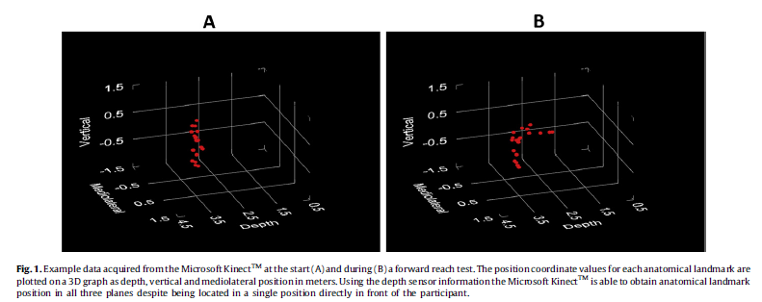

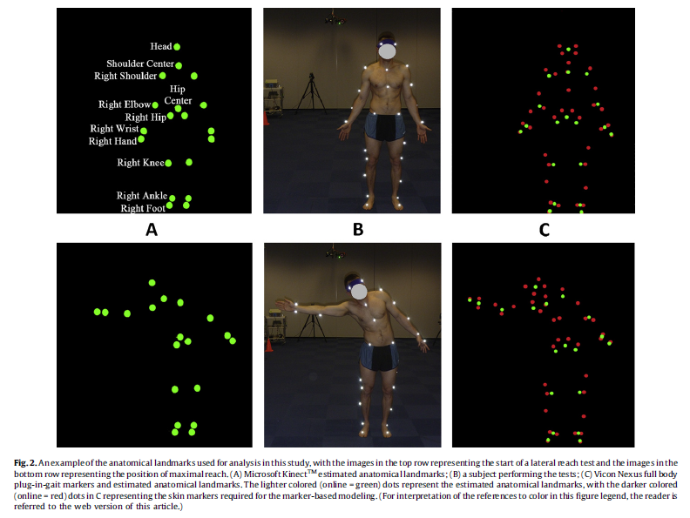

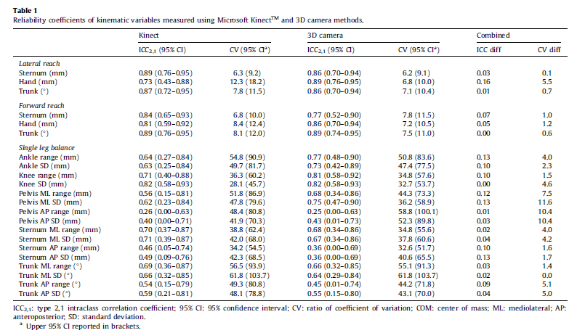

**STATISTICAL ANALYSES**

Statistical, Excel and R programmes were used in this research.

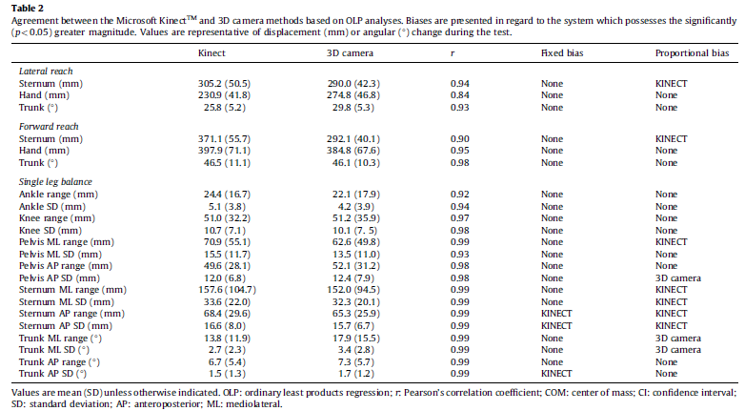

**DISCUSSIONS**

Our results suggest that the Microsoft Kinect v1 provides anatomical landmark displacement and trunk angle data which possesses excellent concurrent validity when compared to data obtained from a 3D camera-based motion analysis system.

Advantages of the Kinect system is that the system has more than one sensor, it does not require markers, it is inexpensive and portable.

# **Accuracy of the Microsoft Kinect Sensor for Measuring Movement in People with Parkinson’s Disease**

**ABSTRACT**

The Microsoft Kinect v1 sensor is potentially low-cost solution for clinical and home-based assessment of movements symptoms in people with Parkinson’s Disease(PD). The purpose of this study was to establish the accuracy of the Kinect measuring clinically relevant movements in people with PD.

**INTRODUCTION**

Parkinson’s disease is a multi-system neurodegenerative disorder that impairs postural control and mobility, leading to reduced community ambulation and increased risk of slips, trips and falls. Conventional 3D video-based motion analysis systems allow for comprehensive kinematic analysis of movement in PD. However, these systems require large spaces and they are expensive and, they require considerable expertise. Instead of using clinical assessment tools we can use Kinect sensors at home without any expensive equipment.

**METHODS**

**Subjects:**

* 9 people(6 females, 3 males) with mild-to-moderately severe PD.
* Age and gender was not the focus of this study.

**Microsoft Kinect System:**

* 20 anatomical landmarks
* 30 Hz frequency
* Spatial and depth resolution of 640x480 pixels

**Vicon Motion Analysis System:**

* 10MX3+ infrared camera
* Plug-in-gait full body marker set
* Two additional markers for thumb and index finger
* Vicon calibration for marker position with 100 Hz frequency

**PROCEDURE**

Subjects performed a series of clinically functional movements and these movements concurrently monitored with Kinect and Vicon. Participants stood directly facing the Kinect sensor at a distance of 3 meters, which is sufficient to collect accurate data. The Kinect sensor was positioned 1 meter from the ground, with the lens perpendicular to the floor and pointing toward to participant.

**DATA PROCESSING AND ANALYSIS**

In this article they simplified the comparison of the Kinect and Vicon by using either range of motion of a single marker or two-dimensional sagittal and frontal plane kinematics. The mean range of motion and timing of each repetition were used as outcomes except sit-to-stand which was expressed as the total duration of the test in keeping with standard clinical reporting, and mean trunk flexion which was calculated over 10 seconds of still standing. The Kinect skeletal model did not allow for measurement of forearm pronation/supination directly. Therefore, they measured the vertical displacement of the wrist for each repetition. The mean bias between the two systems determined using a two-sided t-tests. Pearson’s r correlation was used for between systems agreement. Absolute accuracy is determined using intra-class correlation (ICC2,1). Bland and Altman plots were used to inspect the error scores between the two systems.

**RESULTS**

The ten control participants (Mean age:27.5 years, 5 females, 5 males) and the 9 people with PD completed the test without any incident. As its shown on the table below you can see the temporal and spatial accuracies.

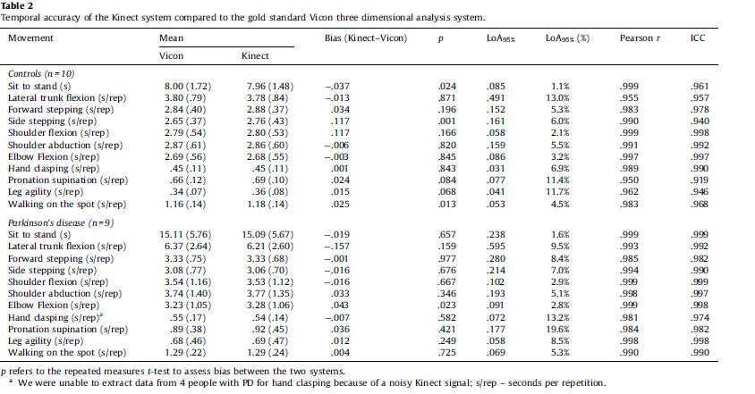**Temporal accuracy:**

**Spatial accuracy:**

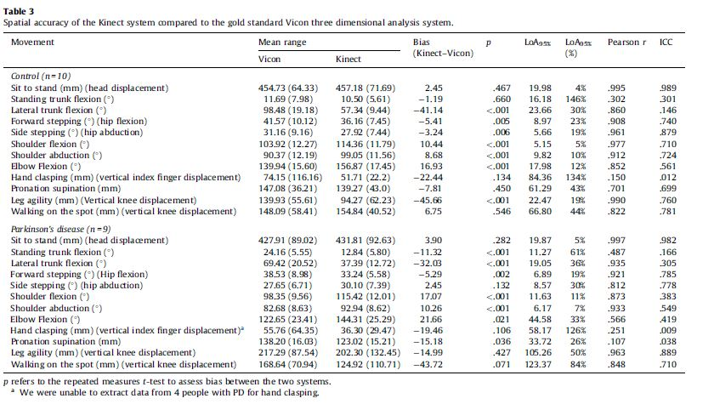

**DISCUSSION**

Kinect was able to accurately measure timing of clinically relevant movements in people with PD and, to a lesser extent, the range of motion of these movements. These results contributed to the goal of developing the Kinect as a low-cost system for monitoring PD movement symptoms in the home. Kinect was able to measure timing of the movements well; however, it was not quite well measuring those movements spatially. The newer Xbox One Kinect sensor (Kinect v2) will have improved spatial and temporal resolution, potentially improving the accuracy of the fine movements, such as hand clasping and toe tapping and facilitate more precise anatomical models.

# Kinematic Validation of a Multi-Kinect v2 Instrumented 10-Meter Walkway for Quantitative Gait Assessments

**ABSTRACT**

Walking ability is frequently assessed with the 10-meter walking test (10MWT), which may be instrumented with multiple (4) Kinect v2 sensors to complement the typical stopwatch-based time to walk 10 meters or gold standard systems such as Optotrak cameras with smart markers. Using the infraclass correlation coefficient(ICC) Kinect v2 sensors’ accuracy can be obtained by comparing with Optotrak motion registration system (i.e., gold standard). Also using the ICC, we can obtain the absolute accuracy of Kinect v2. Kinect v2 set-up used to automate 10MWT assessments with a quick, unobtrusive and patient-friendly manner.

**INTRODUCTION**

Kinect v2 sensor has a time-of-flight camera with a increased resolution of the depth image, a wider field of view and improved body point tracking, because of this it allows us to use for motion registration in a quick and affordable manner. Since the multi Kinect v2 set-up has not yet been validated for 3D full-body motion registration, its performance will be compared to a gold standard in 3D measurement accuracy (i.e., Optotrak active-marker 3D optical tracking system, Northern Digital Inc., Waterloo, Canada). The between systems agreement will be examined for raw data (i.e., body point’s time series) and spatiotemporal gait parameters (e.g., step length, cadence and step width). In addition, the between-systems agreement for the performance measure of the 10MWT will be assessed between the multi-Kinect v2 set-up, the Optotrak motion-registration system (i.e., gold-standard reference) and the stopwatch (i.e., the clinical standard).

**METHODS**

**Subjects**:

* 21 healthy subjects (11 males,10 females)
* Age mean:30.2 years
* Height mean: 176.1 cm
* Weight mean: 70.5 kg

Subjects did not have any medical condition that would influence walking.

**Experimental set-up and procedure:**

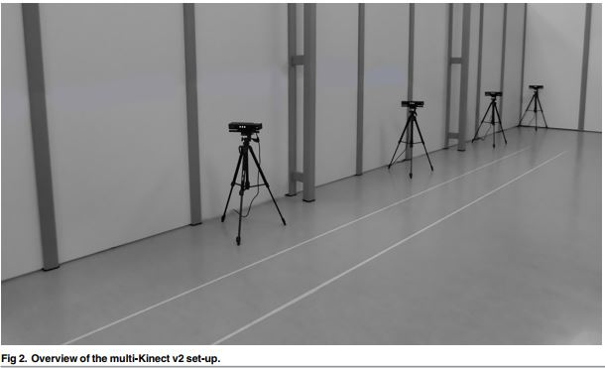Full body kinematics was recorded with four spatially and temporally integrated Microsoft Kinect v2 sensors and the Optotrak system. Kinect v2 set-up is shown in Fig2.

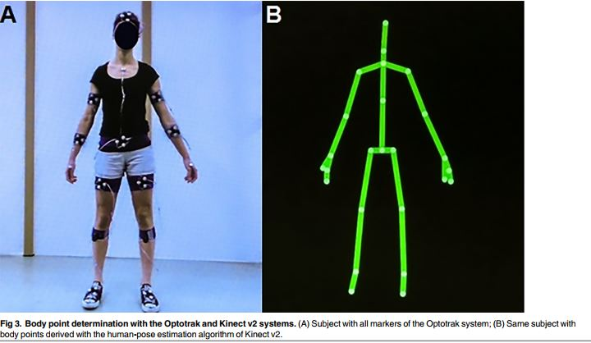The four Kinect v2 sensors were positioned on tripods alongside a walkway of 10 by 0.5 meters at a height of 0.75 meters. The sensors were placed 0.5 meters from the left border of the walkway with an angle of 70 degrees relative to the walkway direction. The first sensor was positioned at 4 meters from the start of the walkway. The other three sensors were placed at inter-sensor distances of 2.5 meters. In addition, five Optotrak cameras (i.e., a combination of two Optotrak 3020 and three Optotrak Certus cameras, which are compatible with each other) were positioned around the walkway to cover the same area as the multi-Kinect v2 set-up. The coordinate systems of the multi-Kinect set-up and the Optotrak system were aligned using a spatial calibration grid. The Kinect for Windows Software Development Kit (SDK 2.0) has a sampling rate of 30 Hz, the 3D positions of 25 body points. The Optotrak system has a sampling rate of 60 Hz. In addition to Optotrak cameras Smart Marker Rigit Bodies (Nothern Digital Inc., Waterloo, Canada) were attached to the different body parts as shown in Fig3.

Subsequently, subjects performed the 10MWT at two different walking speeds, which are comfortable walking speed (CWS) and maximum walking speed (MWS). Both conditions were performed three times in a fixed order in order to have a precise result.

**Data preprocessing:**

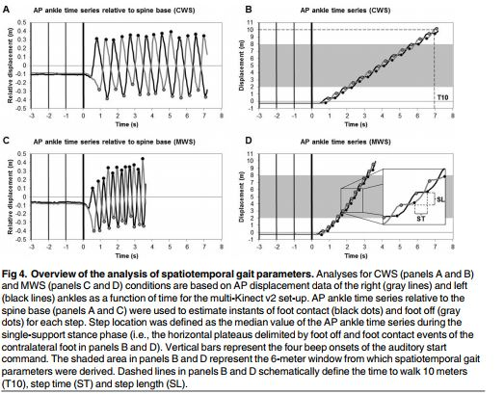The 3D positional data of body points were first pre-processed per Kinect sensor separately. Since the sampling frequency of the Kinect is not constant (ranged from 32 ms to 34 ms), the body point’s time series were linearly interpolated using Kinect’s timestamps to ensure a constant sampling frequency is 30 Hz, without filling in the parts with missing values. Optotrak data was downsampled to 30 Hz in order to have paired time series in the mediolateral(ML) and vertical(V) directions. These time series were interpolated with a spline algorithm in case of missing data. No time series were excluded for the multi-Kinect v2 set-up, whereas 17 out of 2394-time series were exluded from Optotrak, the remaining data were interpolated again with a spline algorithm. Several gait parameters were calculated from the body point’s time series, separately for both measurement systems.

The performance measure of the 10MWT was defined as the time from final beep onset until the moment that the most forward ankle passed the 10-meter line.

**DATA ANALYSIS**

The between-systems agreement was calculated for the body point’s time series from final beep onset until the moment that the most forward ankle passed the 10-meter line. For the anterior-posterior(AP) direction, the trend was removed using a bidirectional, second-order Butterworth high-pass filter (cutoff frequency of 0.5 Hz) to reduce of a large within-subject variation on the agreement statistics, which would become arbitrarily high. Intraclass-correlation coefficient for consistency (ICC(C,1)) is used for systems agreement for Optotrak and Kinect v2. In this article they regard ICC values above 0.6 as good and ICC values above 0.75 as excellent. ICC(A,1) values were complemented by mean differences and precision values obtained with a Bland-Altman analysis (i.e., the bias and the limits of agreement,respectively). For the spatiotemporal gait parameters, the average was hence also constructed over the three trials per condition per subject.

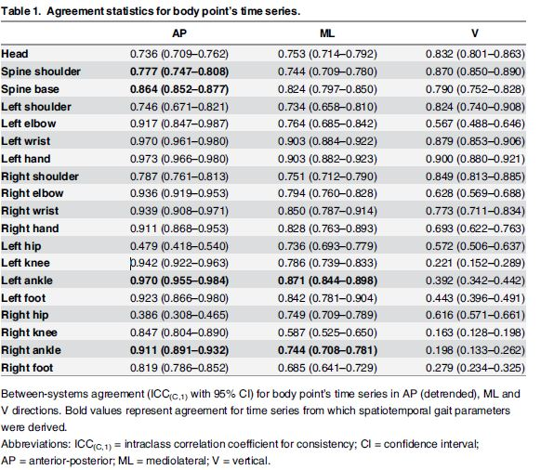**Agreement between body point’s time series:**

**Agreement of spatiotemporal gait parameters:**

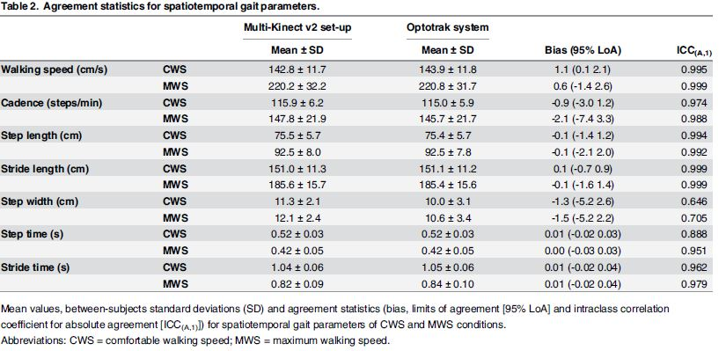

**Agreement of time to walk 10 meters:**

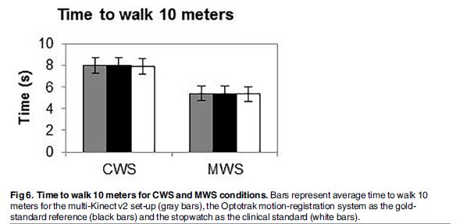

**DISCUSSION**

In this article they observed a good to excellent agreement between the two motion-registration systems for raw data, spatiotemporal gait parameters and time to walk 10 meters. However, with a small range of motion, the noisier Kinect v2 data may have caused the error-variances of the two motion-registration systems to differ, with consequently a lower between-systems agreement. Previous study about Kinect v1 using in Parkinson’s Disease assessment also proved that small movements such as hand-clasping, toe tapping is hard to detect spatially.

# Biomechanical Validation of Upper-body and Lower-body Joint Movements of Kinect Motion Capture Data for Rehabilitation Treatments

**ABSTRACT**

A comparison study between Kinect v1 and an optical motion capture professional system is done.

**RELATED WORK**

**Motion capture and rehabilitation:**

The interest of some video games researches towards use video games in physiotherapy, occupational therapy and psychotherapy increased last years. By developing a serious game as a rehabilitation tool, the motivation associated to games is achieved. Low cost technologies like webcams bring the possibility to capture patient movements in order to complement the process of rehabilitation, without losing control on the patient when they are at home.

**Kinect v1’s precision:**

The results are difficult to compare because they work with a static scene and not with motion capture data that also involve errors in the obtained skeleton.

**EQUIPMENT DESCRIPTION**

**Optical motion capture:**

The system consists in a set of cameras 4 to 32 and a computer that manages them. Usually, the actor takes some markers that are active and passive. Cameras can capture frame between 30 to 2000 per second. After capture sessions, motion data is cleaned trying to remove noisy data and recovering missing markers. This clean and accurate data is used as a reference for testing Kinect’s mobcap accuracy. The work was held in the MediaLab facilities, which has 24 Vicon MX3 cameras.

**Kinect v1’s motion capture:**

Kinect device has an approximate depth limitation from 0.7 to 6 meters. Horizontal angular field of view is 57𝑜 and 43𝑜 vertically. Horizontal field of view has a minimum distance around 0.8 meters and 0.63 meters in vertical, so Kinect has an approximate resolution of 1.3 millimeters per pixel.

Thus, Kinect is a device capable to extract color and depth information from scenes. In order to use Kinect as a motion capture system we need a specific software connected to it. OpenNI and Primesense’s NITE (Natural Interaction Technology for End-user) have been used.

**EXPERIMENTAL ANALYSIS**

**Capture description:**

Kinect was placed in front of the actor at an approximate distance of 2 meters. In case of the optical motion capture, cameras cover the capture volume with multiple views.

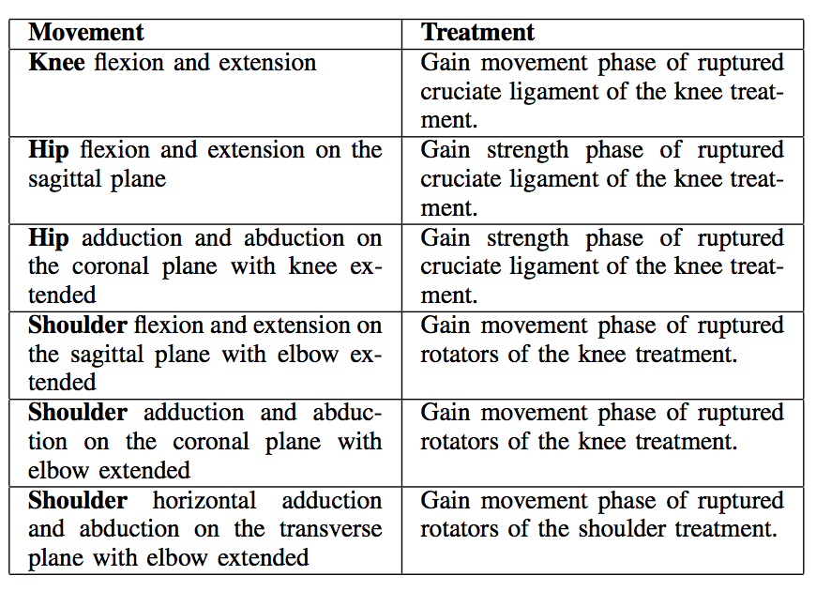

**Optical motion data:**

A configuration of markers was set to calculate joint positions from markers. 2 markers were placed in each join for Kinect to be able to track. Motion data was recorded in 120 frames per second and were expressed in world coordinate system.

**Kinect v1’s motion data:**

NITE user tracking algorithm was used, and the joint specifications was referred to the world coordinate system. As expected, estimated positions by Kinect suffer some noise, because tracking algorithm recomputed at each frame all joint specifications regardless of temporal continuity, this fact produces. To remove this noise, a smooth low-pass filter was applied (5 frames of time window).

**Data correspondence:**

To make comparison between them, the optical motion capture data was converted to the representation of the Kinect motion data. Initially data acquired was rescaled, optical system to 120 fps and to Kinect to 30 fps.

Motions were unsynchronized thus capture systems were independent manually activated. To fix this, the actor was told to lower the arms just after staying t-pose in order to create a specific pattern.

Then, the same movement from both systems was aligned in terms of coordinate system. Optical motion data is reported in its world coordinate system. Optical motion data is reported in its world coordinates (Figure 4 - (a)), and the same for Kinect data (Figure - 4 (d)). Both coordinate systems have the same orientation, but they have exchanged axes. This was corrected this as shown in Figure 4 - (b).

**Rotational data:**

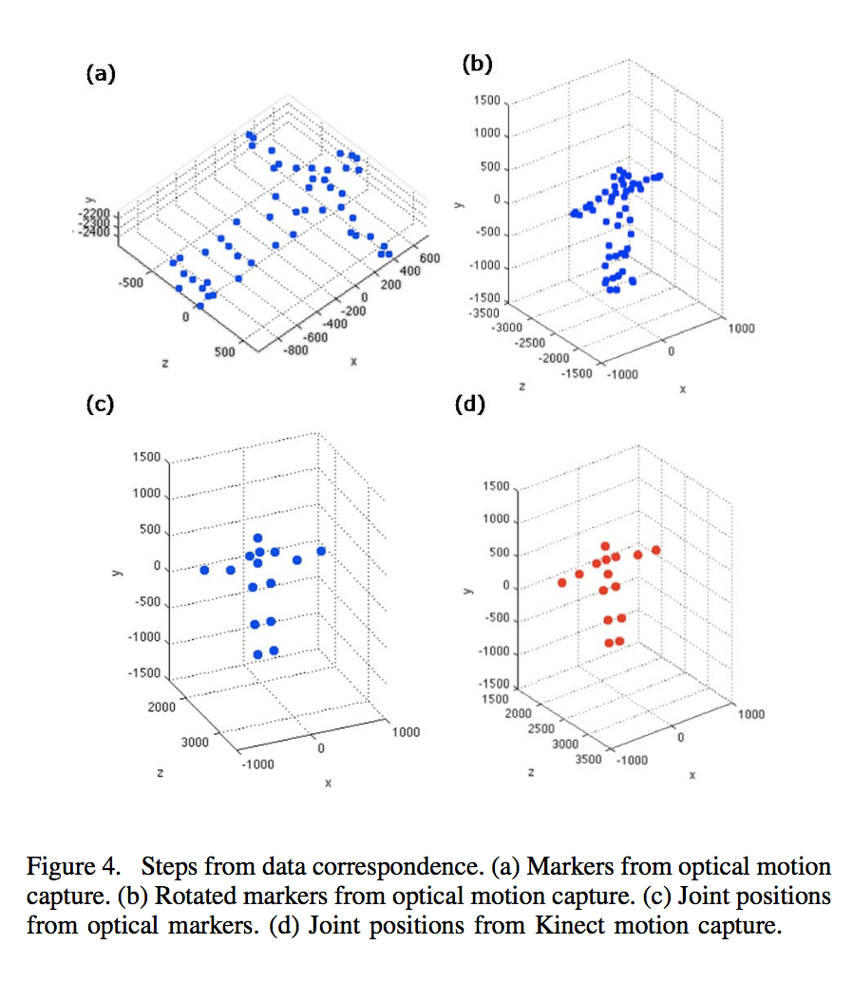Knee rotation, and hip and shoulder rotations were computed respect to the body planes. To achieve this, the calculation of knee rotation and the rest is distinguished. Knee rotation is the angle between two vectors, because it has only one degree of freedom.

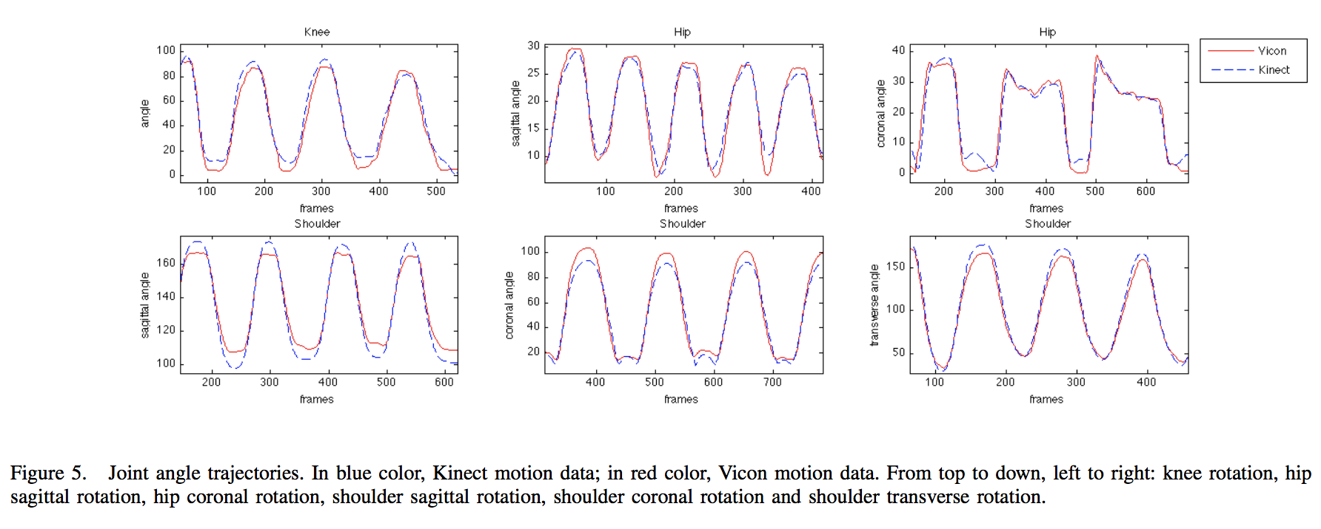**RESULTS**

**Precision study:**

Signals from Kinect and Vicon systems have an evidence correlation because, they are synchronized and follow the same pattern. To measure the accuracy, the mean error (ME) and the mean error relative to range of motion (MER) for each motion clip was calcultaed. MER is calculated by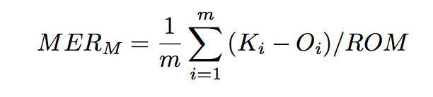

where M is a motion clip, m is the frames length of motion clip M, Ki and Oi are joint angle from Kinect motion capture and optical motion capture in frame i respectively, and ROM is the range of motion.

The rotation comparisons have been done for knee, hip and shoulder joints. In the case of knee, they can summarize results in Table II. All degree error are lower than 10 ranging from 6.78 to 8.98. Dynamic ranges of motion are between 89 and 115. The mean error is increasing when Range of Motion is higher. It occurs because in extreme rotation leg is perpendicular to Kinect camera doing 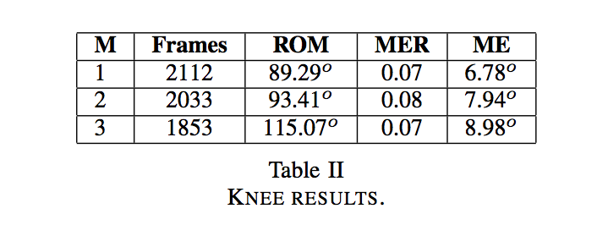more difficult to track hip and knee.

The results are good enough for some psychical therapies based on repetitions, because nowadays therapists visually control the range of motion and it is assumed that is has at least 10 approximate error.

In the case of hip, they have compared sagittal and coronal rotation. In Table III, there are hip results. Sagittal Mean Error is around 5 and coronal is ranged from 6 to 10. Sagittal Mean Error of Range of Motion are around 90 and coronal are 77 and 38. Errors in sagittal movements are lower 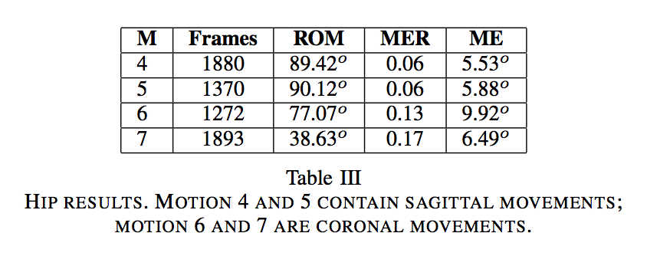than the other cases, however errors in coronal plane are lower than 10.

**CONCLUCIONS AND FUTURE WORK**

The precision of the Kinect is, of course, less than the optical motion capture system, but has several other advantages; price, portability and markerless. The precision ranks obtained for the main joints of the body allows as to confirm that Kinect can be a very useful tech in present rehabilitation treatments.

1. Discussion

According to the papers we have studied, despite the fact that Kinect v1 has overall great skills in motion analysis, when it is compared with accepted methods, such as Vicon etc., it is not accurate and precise enough for clinical applications.

On top of the hardware based insufficiencies such as resolution, IR range, angle of view, software based inadequacies such as joint numbers, tracking accuracy, estimation make Kinect v1 not suitable for our scope.

On the other hand, the newer version of the Kinect, v2, is developed enough to compensate the previously mentioned inabilities of Kinect v1. Therefore, Kinect v2 will be employed in our motion analysis framework.

1. Conclusion

The framework we are developing will be specified for the requirements of Asst. Prof. Dr. Şermin Tükel’s project. The aim of the project is to analyze the motor learning abilities of the kids with autism, processing their upper – extremity data.

The procedure of upper - extremity motion capture requires at least 2 Kinect v2 cameras for adequate accuracy and precision from different angles. For this reason, a calibration algorithm must be applied beforehand as a part of the framework.

[Review + next steps]

“ Projenin İsmi “ belongs to Şermin Tükel. Therefore, specs of the system will be configured according to the requirements, scope and the aim of the project. In order to set the configuration reasonably, we did literature research, and feasibility study. These studies consist of, Kinect V1 and V2 validation on disease diagnosis and rehabilitation.

Most of the papers we have studied take Vicon, that uses its own Nexus software to track skeletal joints as the benchmark whereas Kinect V1 uses Microsoft SDK 1.x. With the captured data from both systems we are able to diagnose and track the rehabilitation process of high variety of samples.

In papers [1] [2] and [3] for upper extremity tracking (i.e. arm, shoulders, etc.) Vicon system is taken as a benchmark showing high…

Vicon, as a proven system, shows higher results of accuracy when compared Kinect V1.

Vicon and Kinect V1 were used in the papers, tracks join movement to diagnosis movements and rehab movements.whereas Vicon uses skeleton tracking algorithms, Kinect uses its own SDK for skeleton tracking. The validation for Kinect v1 in given tasks was compared the results from Vicon, since Vicons results are accepted as quite accurate.

When describing the Vicons accuracy use notation from the referred articles

References

[1] A. Fernández-Baena, A. Susín and X.Lligadas. Biomechanical Validation of Upper-body and Lower-body Joint Movements of Kinect Motion Capture Data for Rehabilitation Treatment. *2012* *Fourth International Conference on Intelligent Networking and Collaborative Systems 978-0-7695-4808-1/12*

[2] Alexandra Pfister, Alexandre M. West, Shaw Bronner & Jack Adam Noah (2014) Comparative abilities of Microsoft Kinect and Vicon 3D motion capture for gait analysis, Journal of Medical Engineering & Technology, 38:5, 274-280, DOI: 10.3109/03091902.2014.909540

[3] R.A. Clark, Y. Pua, K. Fortin, C. Ritchie, K. E. Webster, L. Denehy, A. L. Bryant. Validty of Microsoft Kinect for assessment of postural control, *Gait & Posture 36, 372 – 377, 2012*

[4] D. Córdova – Esparza, J.R. Terven, H. Jiménez – Hernández, A. Vázquez – Cervantes, A. Herrera – Navarro, A. Ramírez – Pedraza. Multiple Kinect V2 Calibration

[5] M. Eltoukhy, J. Oh, C. Kuenze, J. Signorile. Improved Kinect- based spatiotemporal and kinematic treadmill gait assessment, *Gait & Posture 51,77 – 83, 2017*

[6] S. Lee, Y. Lee, J. Kim. Automated Evaluation of Upper – limb Motor Function Impairment using Fugl – Meyer Assessment, *DOI 10.1109/TNSRE.2017.2755667*, 2017

[7] Geerse DJ, Coolen BH, Roerdink M (2015) Kinematic Validation of a Multi-Kinect v2 Instrumented 0-Meter Walkway for Quantitative Gait Assessments. PLoS ONE 10(10): e0139913. doi:10.1371/journal.pone.0139913

[8] B. Galna, G. Barry, D. Jackson, D. Mhiripiri, P. Olievier, L. Rochester. Accuracy of the Microsoft’s Kinect sensor for measuring movement in people with Parkinson’s disease, *Gait & Posture 39*, 1062 – 1068 , 2014

[9] M. Kowalski, J. Narunier. Livescan 3D: A Fast and Inexpensive 3D Data Acquisition System for Multiple Kinect V2 Sensors,

[10] R. J. Adams, M. D. Lichter, E. T. Krepkovich, A. Ellington, M. White, P. T. Diamond, Assessing Upper Extremity Motor Function in Practice of Virtual Activities of Daily Living, IEEE Transactions on Neural System and Rehabilitation Engineering, Vol. 23, No. 2, 2015